My Care Plan

When I am feeling well, my ____________________ (mom/dad) come(s) in and . . .
□ changes my diaper | □ does NNS (non-nutritive sucking)
□ takes my temperature | □ breastfeeds me
□ holds my feed | □ bottle feeds me
□ holds me (skin to skin) | □ I like to suck on my pacifier
□ bathes me | □  ________________________________
□  ________________________________ | □  ________________________________

My Feeding Plan now is: ________________________________________________
______________________________________________________________________
_______________________________________________________________________

My mom/dad come(s) in: ________________________________________________
I really like it when: _________________________________________________
My favourite position is: _______________________________________________

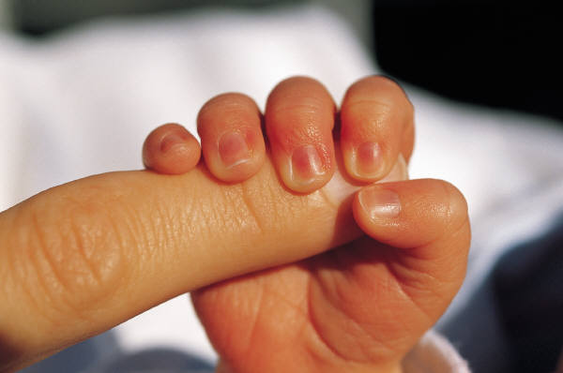
Thanks for taking great care of me,

Baby’s Name: __________________________________
Date: _________________ ________________________

